WEATHER APP
AIM: In this web development assignment, you will create a web-based music player application using HTML, CSS, and JavaScript. The project aims to provide hands-on experience in building a user-friendly and interactive music player that can play audio files.
IMPLEMENTATION:
- Created this music palyer app project using,
- Html for structuring the app.
- CSS for layput and styling
- Javascript for integrating and for ffetching weather data

- The app displays the details such as,
- Login page
- Register Page
- Home page
- Library page
- About us page
- Pause, play, forward, backward, user-choice slection of songs from random

- Basic features included,
- User interface: Designed a clean and intuitive user interface for the music player. It includes controls such as play, pause, volume adjustment, and a progress bar, forward, backward options.
- Audio Playback: Implemented the ability to play audio files. Used HTML5's audio element to handle audio playback.
- Playlist: Allows users to create a playlist of songs to play and add it to the library page.
- Play, Pause, and Seek: Users will be able to play and pause the audio, as well as seek to different parts of the song using the progress bar.
- Volume Control: Includes a volume control slider to adjust the audio volume.
- Song Information: Displays the current song's title, artist, and album information.
- Styling: Applied CSS to make the music palyer app visually appealing. Ensuring it's responsive and user-friendly.

SCREENSHOTS:
- LOGIN PAGE:
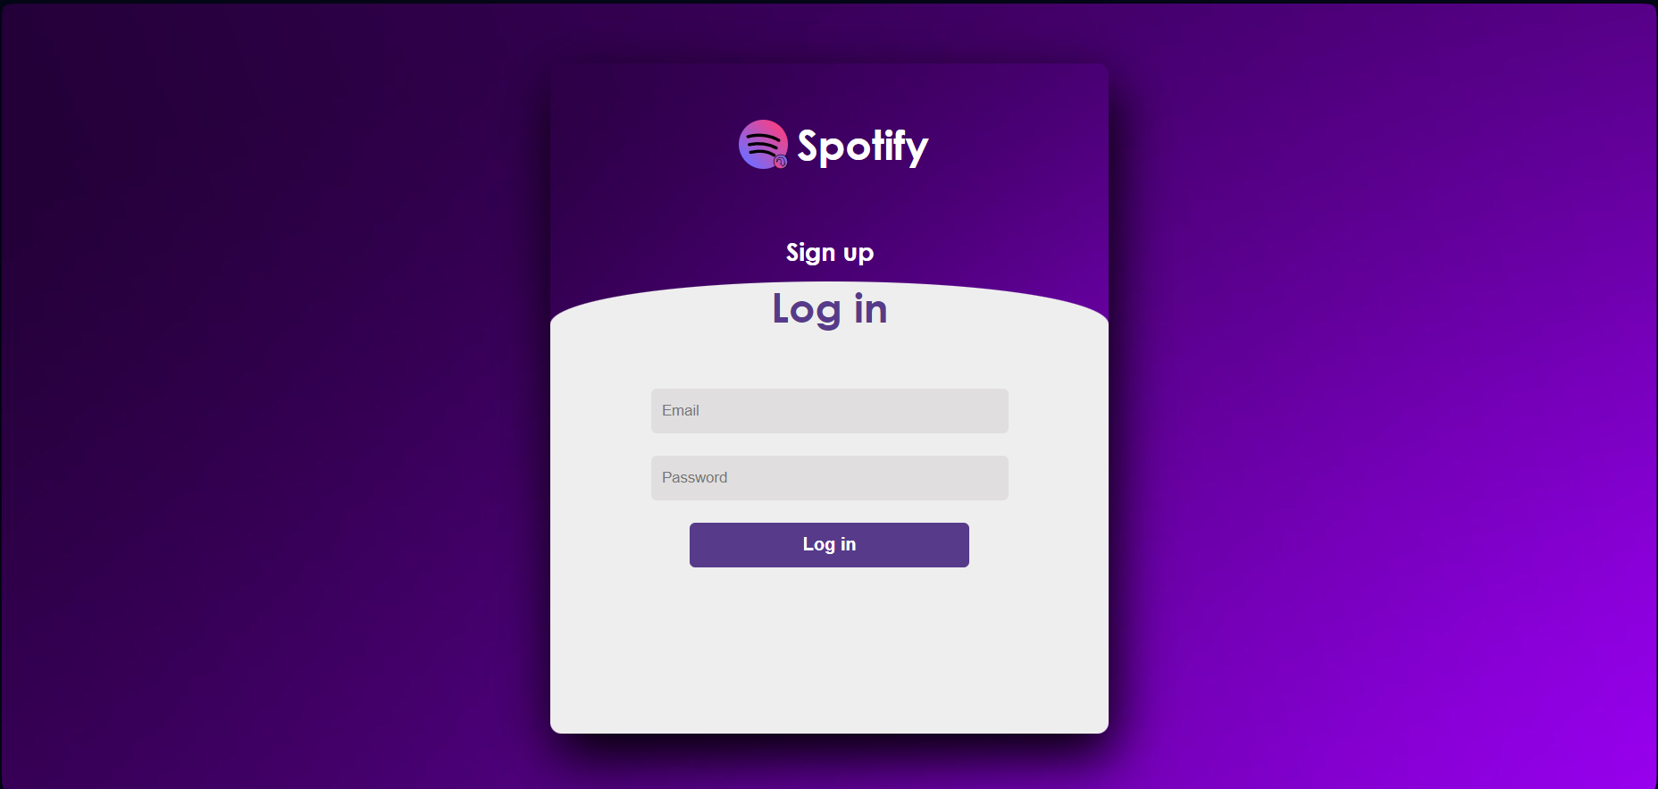

- SIGN-UP PAGE:
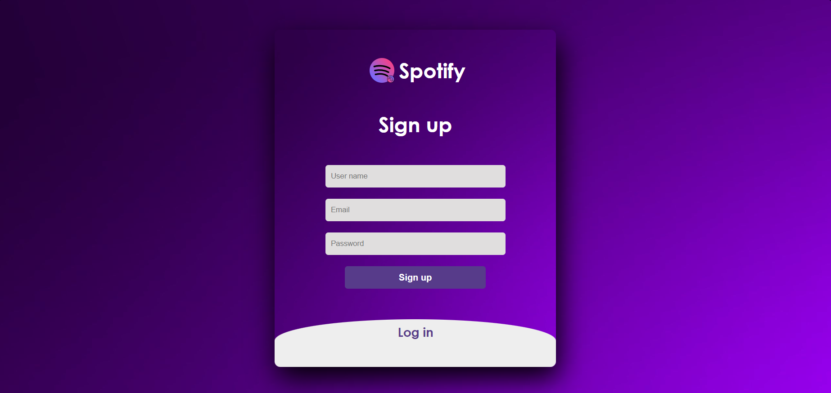

- HOME PAGE:
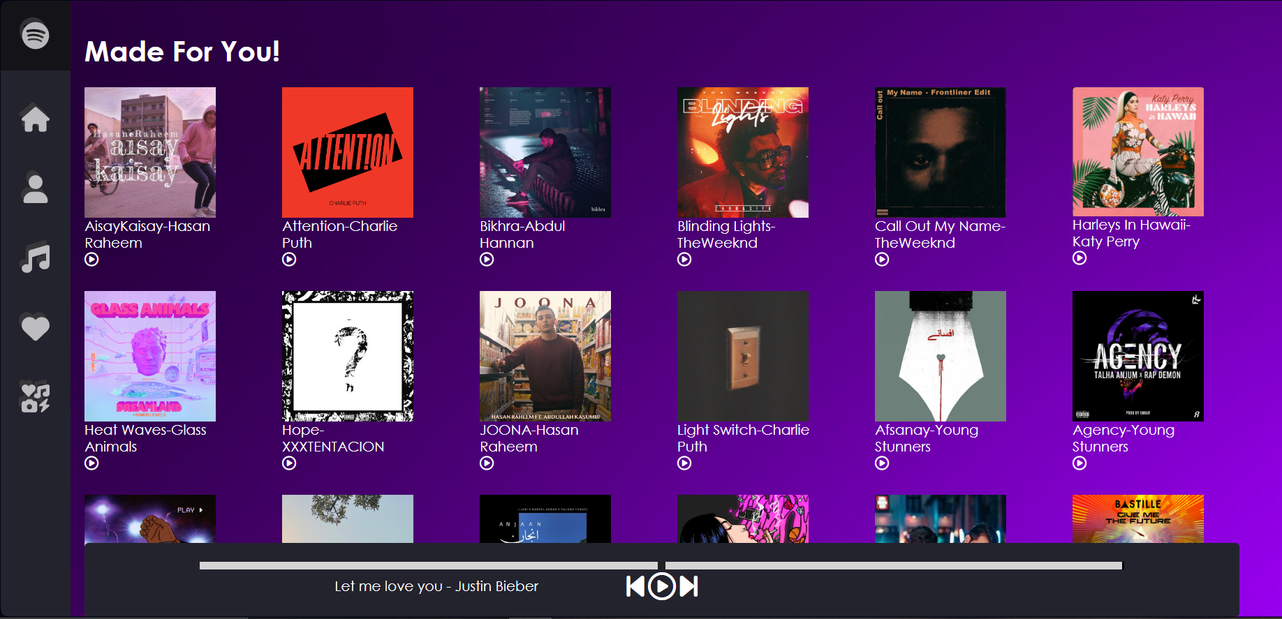

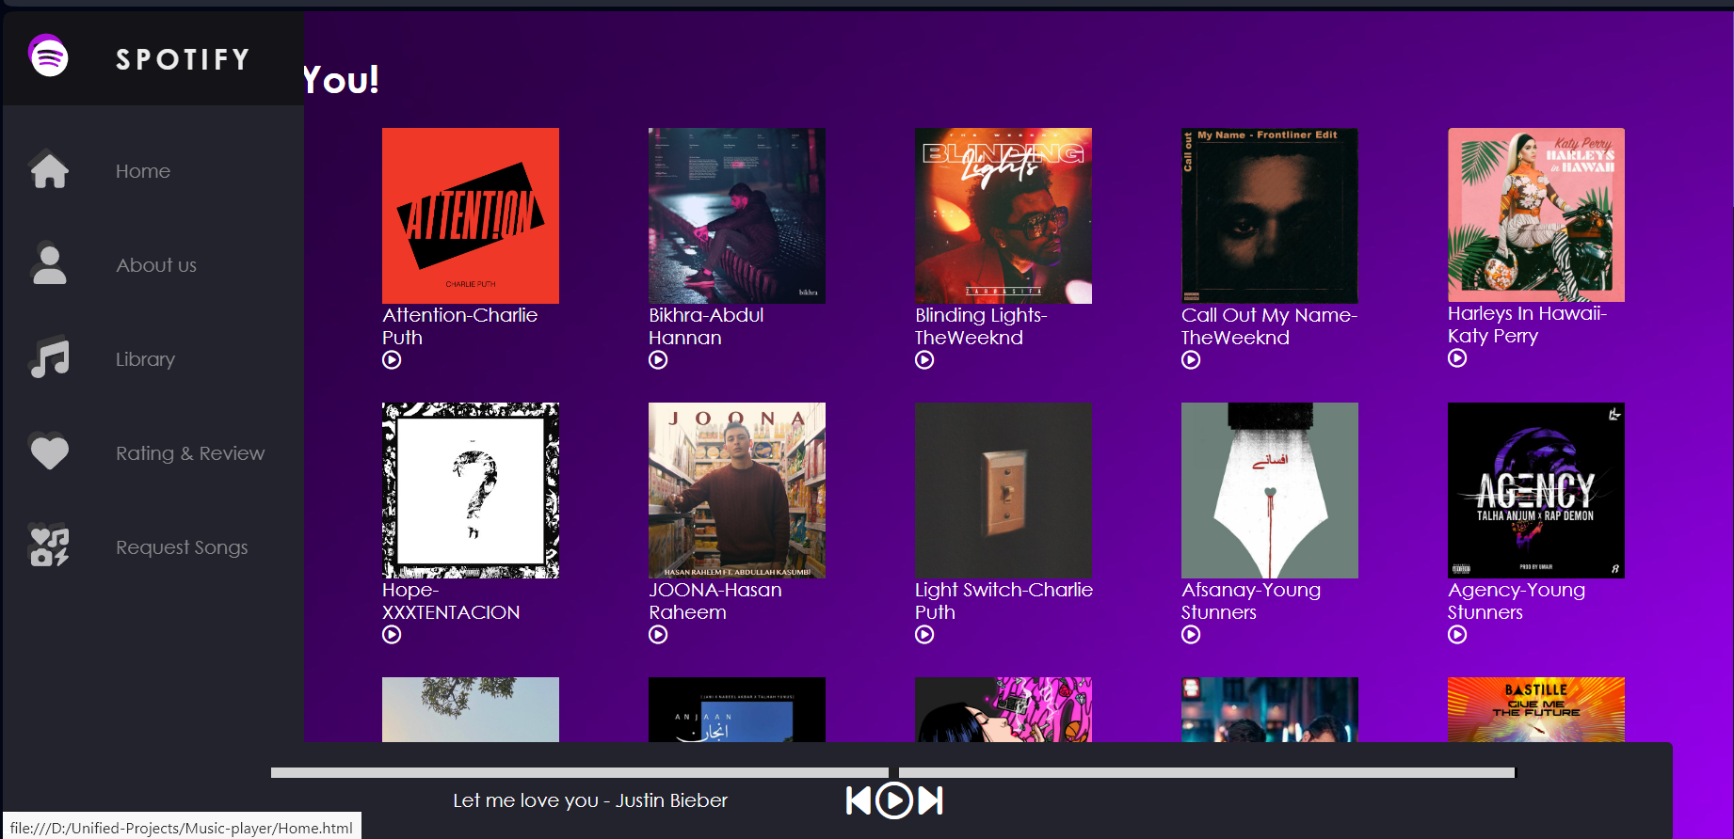

- LIBRARY(PLAYLIST) PAGE:
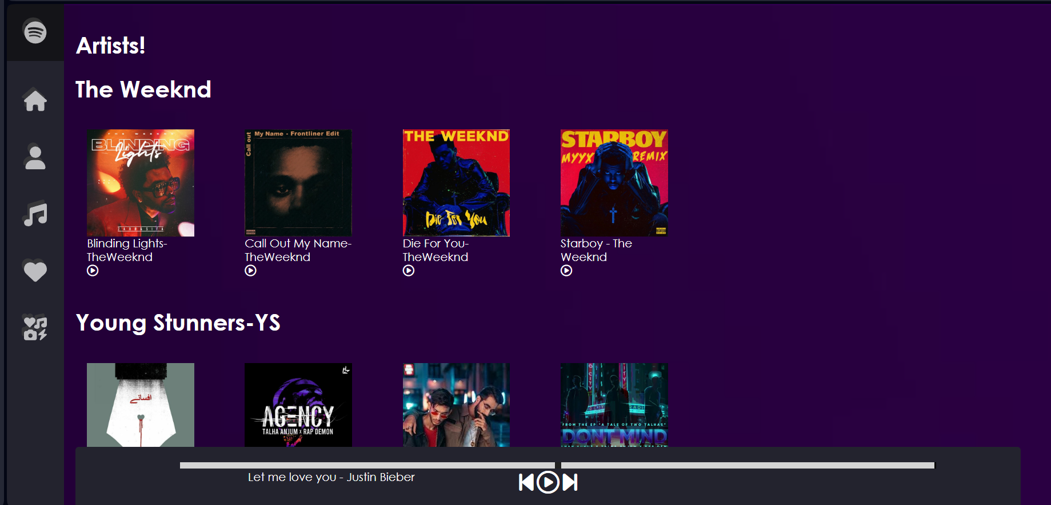

- ABOUT US PAGE:
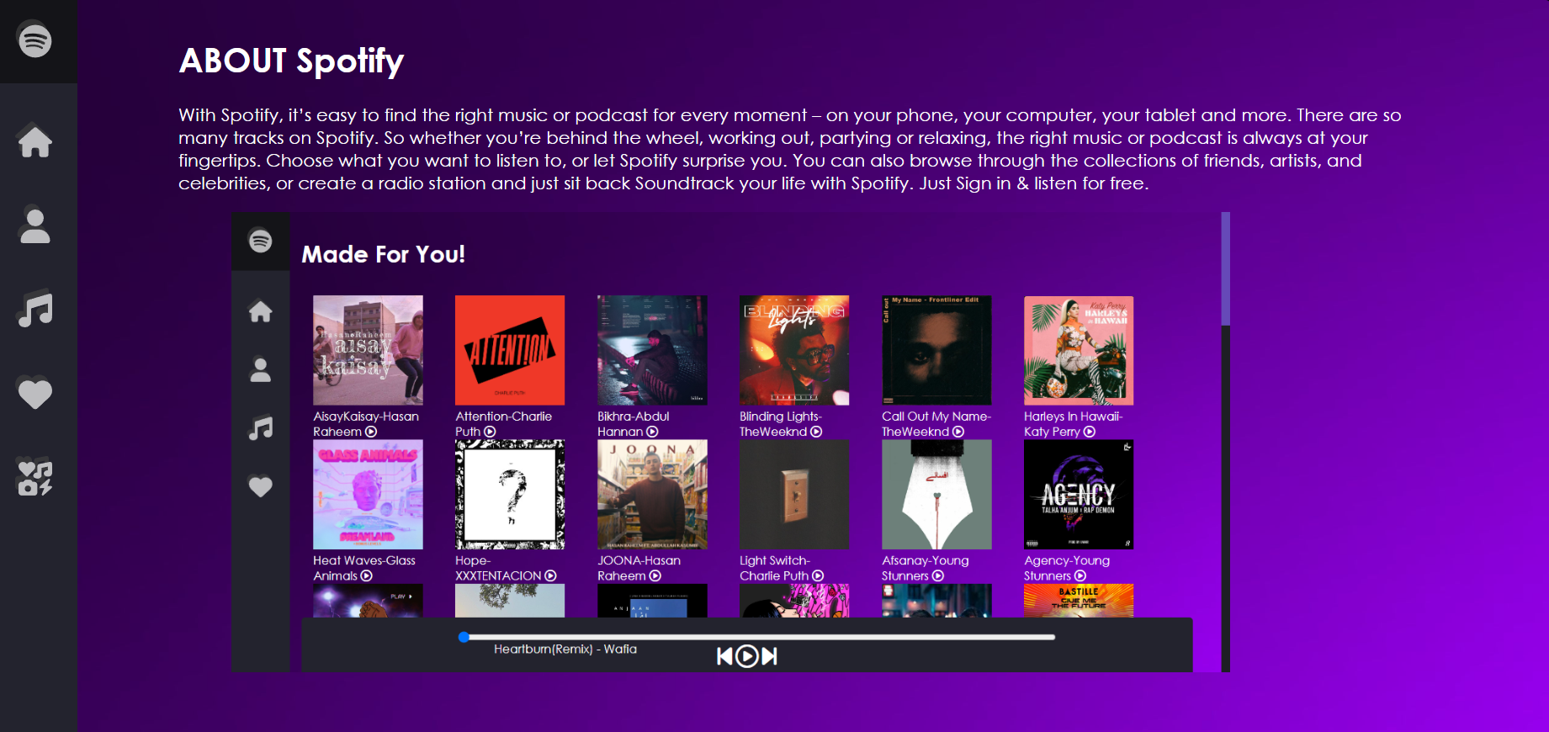

GUIDE TO OPEN THE PROJECT:
- Extract the Music-palyer.zip file from the given drive link into your device.
- After extracting open the Musicplayer folder in your device and run the index.html in your preferred browser or default browser or run the log in.html in your browser to run the project.

